

Noritsu NetOrder Printer Driver for Mac OS X Ver2.00
Requirements specification

NORITSU KOKI CO., LTD.
Ver1.1

Purpose:
This document defines the requirements for “Noritsu NetOrder Printer Driver for Mac OS X Ver2.00”.

Naming Conventions:
- NetOrder: Name of the programming interface to Noritsu printer.
- Errors / Attentions: Error and attention messages which are sent from Noritsu printer. Error messages are generated when a critical error happens (ex. Paper jam, printer system error, printer door is opened while printer is running, etc.). Attention messages are generated when the printer condition has changed which the operator needs to see (ex. Paper is empty, printer door is opened while printer is idle, etc.).
- Back Print: Paper back character printing primarily used for order / print identification.
- Fast Print: When printer is ready for printing, it will not wait for the entire order to be received but start printing as soon as it finishes receiving each image within an order.
- NKC: Noritsu Koki Co., Ltd.
- NAC: Noritsu America Corp.
- Mac PD or Mac Printer Driver: NetOrder Printer Driver for Mac OS X
- M300, D701: Noritsu printer featuring inkjet technology.
- D502, D703: Next generation of the Noritsu printers.

Contact Information:
- Tetsuya Wada, Manager, CEO Office, Noritsu Koki Co., Ltd. t-wada@nkc.noritsu.co.jp
- Nobuhiro Tsujioka, Assistant Supervisor, CEO Office, Noritsu Koki Co., Ltd. n-tsujioka@nkc.noritsu.co.jp

Requirements:

All functions of Ver 1.00 must be covered excluding the items described in this document.

- Installation
- This software shall base on Noritsu NetOrder Printer Driver for Mac OS X Ver1.00.
- Ver.2.00 software can be installed to the PC where Ver1.00 is already installed.
- Ver2.00 software can be newly installed.
- Existing setting data should be used after upgrading the software from Ver1.00 to Ver2.00.
- This software can be uninstalled.

- Duplex print support

  - Print Dialog

    - Print setting (Layout) Display
- When a Noritsu Printer capable of duplex printing (e.g. D502) is selected, make the “Two-Sided” option enable.

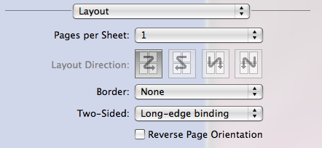

    - Noritsu Paper Magazine Display

(The screen capture below is from v1.0.)
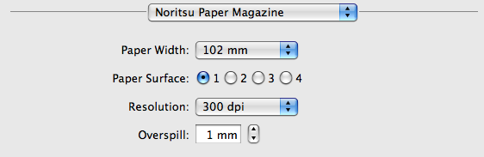

Proposed changes for v2.0
--------------------[ Noritsu Paper Magazine ]----------------------------

Feeding Method: [ V] *2

Paper Width: [ V]

Paper Name: [ V] *2

Paper Surface: ●1 ○2 ○3 ○4

Resolution: [ V]

Tone: [ V] *3

Overspill: [ ][V]

Binding Margin: [ V] *1

Binding Margin Width:[ ][V] *1

[Reset to Defaults]

- “Binding Margin”, and “Binding Margin Width” are added. (Marked as “*1” in the figure above.)

- “Binding Margin”

- A pop up button that allows user to select the binding position
- Selections of pop up button vary depending on the combination of two-sided setting (2.1.1) and paper size, as shown in the table below.

Two-sided setting | Paper size | Selection items for “Binding Margin”
Long side binding | Paper length gt. Paper width | None, Left, Right
Short side binding | Paper length le. Paper width | None, Left, Right
Long side binding | Paper length le. Paper width | None, Top, Bottom
Short side binding | Paper length gt. Paper width | None, Top, Bottom

- For both combinations “None” is selected by default.
- “Binding Margin” can only be configured when Print Option > Layout > Two-Sided setting (2.1.1) is set to either Long side binding or Short side binding. Otherwise, it is grayed out.

- Binding margin width

- Enter the width of the binding margin in the text box, or specify it with the spin button.
- Input range is 0-50 mm, in 0.1 mm increments.
- Default is 0 mm.
- “Binding Margin Width” can only be configured when Print Option > Layout > Two-Sided setting (2.1.1) is set to either Long side binding or Short side binding. Otherwise, it is grayed out.

- “Tone” is added. (Marked as “*3” in the figure above.)
- Specify the gradation for each paper with the pull-down menu.
- Set the value obtained from printer with QssGetPaperAD().
- Default value is the smallest value obtained with QssGetPaperAD().
- When there is no value that can be used, this item will be grayed out. (QSS_PAPER_TONE_NONE is set internally.)

- When connection with the printer is offline
- Values obtained last will be used. When such values are not available, the default values will be used.

- Timing to obtain setting info
- Every time the Noritsu Paper Magazine dialog is shown, setting info will be obtained from the printer.

    - Noritsu Settings screen
- Setting parameter of back print.
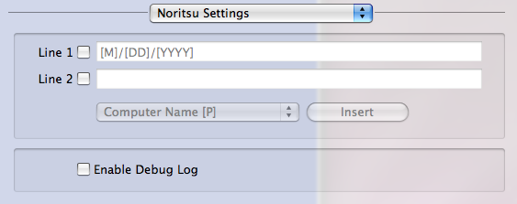
Insert Code
Back Print

- When Layout > Two-Sided setting is set to either Long side binding or Short side binding (which means duplex print is enable), gray out the back print setting to disable back prints.
- Add the “Back Print” and “Insert Code” labels.

  - Creating output image

- If the binding margin width is specified, create the image that includes the binding margin with printer driver.

- In case of odd page image, add the binding margin at the position specified in the binding position setting display.

- In case of even page image, add the binding margin at the opposite position specified in the binding position setting display.

(e.g.) If the binding position of odd page is left, the binding position of even page is right.

- Image allocation
Image area is the area except for the margin and binding area. Allocate the image in the center of the image area.

- In case of the bordered print, add the paper margin and binding margin.

(e.g.) Margin setting of the paper: 5 mm each side, Binding margin width: 10 mm
When Margin setting of the paper is set to 5 mm each side, and Binding margin width is set to 10 mm, the margin of the output image will be:
Side with binding margin: 15 mm (NOT 10 mm)
Side with no binding margin: 5 mm

- In case of the borderless print, add the binding margin and overspill.
(e.g.) Overspill width: 1 mm each side, Binding margin width: 10 mm
Add the 11mm binding margin in the output image, and output the print that includes 10 mm binding margin.

- In case all the following conditions are met, rotate output image 180 degrees before sending the image for printing. (This operation is consistent with rotation of EZ Controller.)

Condition
1.Duplex print setting is long side binding
2. Paper size is not square.
3. Printing image is even page.

For information on creation of images, please refer to the “Noritsu NetOrder PD Ver2.00 Spec Addendum v1(E).xls” file.

- Supporting sheet paper

  - Print Dialog

    - Noritsu Paper Magazine Display

Proposed changes for v2.0
--------------------[ Noritsu Paper Magazine ]----------------------------

Feeding Method: [ V] *2

Paper Width: [ V]

Paper Name: [ V] *2

Paper Surface: ●1 ○2 ○3 ○4

Resolution: [ V]

Tone: [ V]

Overspill: [ ][V]

Binding Margin: [ V] *1

Binding Margin Width:[ ][V] *1

[Reset to Defaults]

- “Feeding Method” and “Paper Name” are added. (Marked as “*2” in the figure above.)

- “Feeding Method”

- A pop up button that allows user to select roll paper or sheet paper
- In case the selected printer only accepts roll paper or sheet paper, show the paper that it accepts and gray out the other.
- In case the selected printer accepts both roll paper or sheet paper, show roll paper by default.

- “Paper Name”

- A pull down menu that allows user to select the paper to use which is got by QssGetPaperAD by NTO API.
- When “Feeding Method” is set to “Roll paper”, this item will be grayed out.
- The top item in the combo box is shown by default.

- “Paper Width”
- When “Feeding Method” is set to “Sheet paper”, this item will be grayed out.

- Supporting foreign languages
- Support Japanese, English, German and French.
- Messages displayed by Noritsu NetOrder Printer Driver for Mac OS X can change according to the language setting of OS.
- NKC translate the messages and provide the resource files of messages. Build them into the installer.

- Output image format
- Output images are created in BMP format.

- Items carried over from ver 1.00
- The Overspill setting will be made in 0.01 mm increments in Noritsu Paper Magazine Display.

- Supplementary note about NetOrder API
- Support the NetOrder API Ver 3.0.0 (Advanced Feature)
- Support the fast print function.
- About the duplex print, sheet paper print and fast print function, read “9.Note for Using s to Use the Advanced Functions” and “10. Note for Using the Fast Print Function” of “NetOrder 3.0.0 API Reference”.

Platform:
- Intel and PPC Macintosh
- Mac OS X 10.6 and 10.5.6 (later version support is preferred)

Operating Environments:
- Application
- Adobe Photoshop CS 4 as front-end application
- Adobe Lightroom 2 as front-end application
- Apple Aperture 2 as front-end application
- Adobe Illustrator CS4 as front-end application

- Noritsu Printer
- Support the following printers in addition to the printers that Ver 1.00 supports.
- M300 (Add the sheet paper support)
- D701 (Add the sheet paper support)
- D502
- D703

Payment:
- Payment of 1/3 when the beta software is released to Noritsu
- Payment of 1/3 when the final software is released to Noritsu
- Payment of 1/3 when Noritsu confirmed no critical problem exists.

Ownership:
Noritsu NetOrder Printer Driver for Mac OS X Ver 2.00 is owned by NORITSU KOKI CO., LTD including the source codes, documentation and application.

Deliverables:
- Printer driver application with installer
- Installation and Operation manual PDF
- Software source codes

Developing schedule (TBD)
- Mid April, 2009 Start the System test and Operation test.
- End of May, 2009 End the System test and Operation test.
- End of May, 2009 Start the pre release test.
- End of June, 2009 End the pre released test.
- End of June, 2009 Ver2.00 master release.

